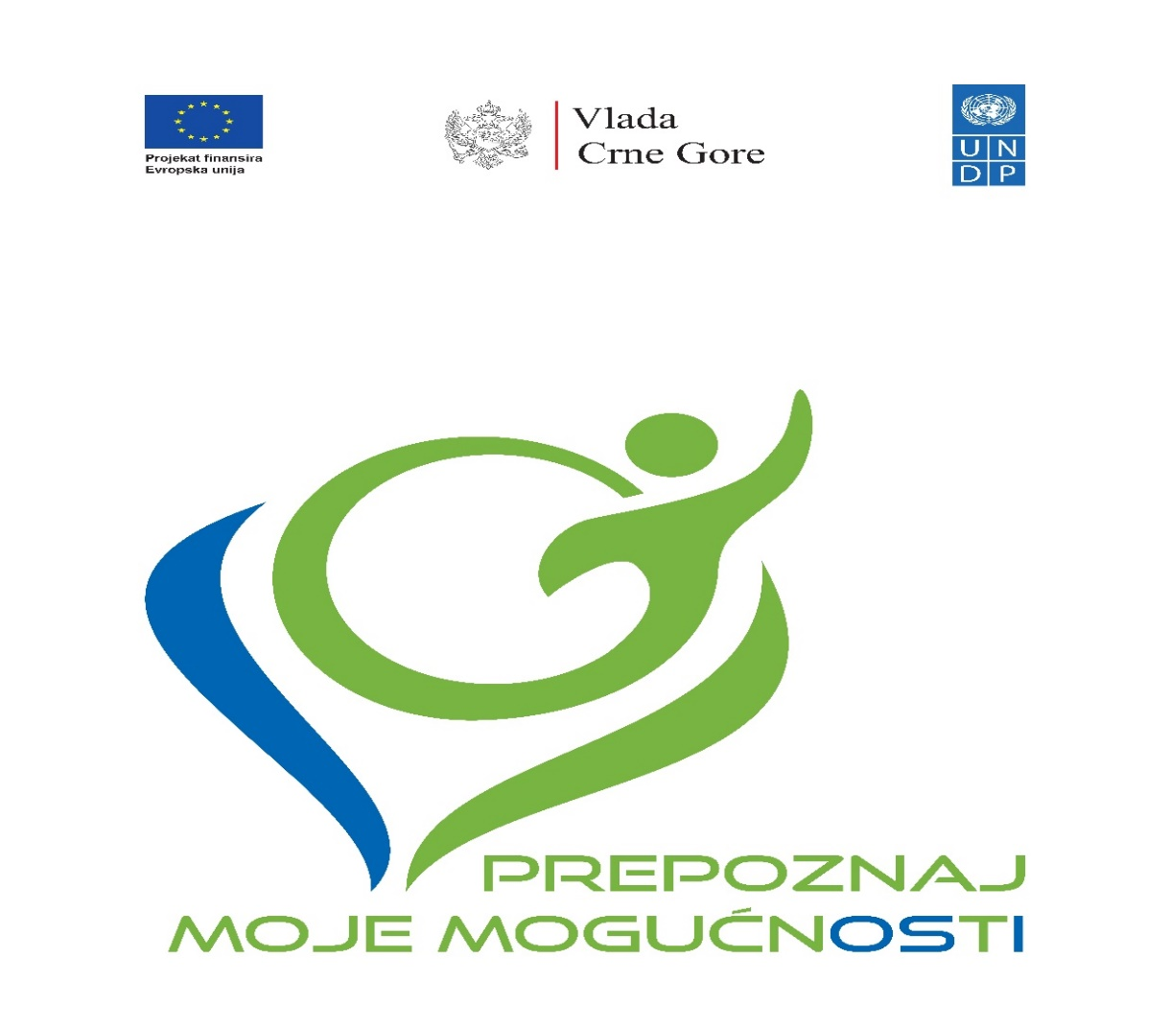

Project “Reform of National Disability Determination System”

First Progress Report
October 2020 - September 2021

Podgorica, November 2021

Table of contents

Summary of the Action 4
Results achieved 5
Activities carried out during reporting period 11
DIFFICULTIES ENCOUNTERED AND MEASURES TAKEN TO OVERCOME PROBLEMS AND EVENTUAL CHANGES INTRODUCED 17
Visibility and Communication 18
Summary of resources deployed during the reporting period 19
Work Plan for the upcoming period 20

List of Abbreviations

DEU | Delegation of European Union
OPD | Organisation of Persons with Disabilities
MFSS | Ministry of Finance and Social Welfare
UN Convention | UN Convention on the Rights of Persons with Disabilities
IWG | Intersectoral Working Group established by the MFSS
SC | Steering Committee
MED | Ministry of Economic Development
MJHMR | Ministry of Justice, Human and Minority Rights
IPH | Institute for Public Health
UNDP | United Nations Development Programme

Summary of the Action

The project enforces a comprehensive, structural reform of the national disability determination/assessment system. The aim of the reform is to set up a single body for disability determination/assessment and establish uniform national criteria and methodology in line with the human-rights based approach. The project is recognized as a priority area by Program of Economic Reforms (2021-2023).
This is a complex reforming venture which includes five sectors: social protection, employment, pension and war veterans, education and health. All the disability entitlements (various cash transfers and social services, disability pensions, employment and professional rehabilitation, education entitlements, various subsidies, etc.), in these sectors for about 50,000 citizens and their families, directly depend on design of disability determination system.
The overall objective is to fully reform the overall national disability determination system for more just, equal and easier access to rights to all kinds of cash benefits and services for persons with disabilities, in line with the national positive legislation and ratified UN Convention on the Rights of Persons with Disabilities (hereinafter: UN Convention). It will be enforced through technical assistance for the development of new (legal and institutional) national disability determination system, capacity building of all line sectors and their professionals and civil servants and raising public awareness among specific target groups and general population.
The specific objective of the project is the reform of the national Disability Assessment and Determination System. The reform will enable persons with disabilities to enjoy fair treatment, easier and equal access to all social security entitlements and better social inclusion prospects, in line with the UN Convention on the Rights of Persons with Disabilities.
Upon establishing of the new system, persons with disabilities will exercise their rights in a more fair and easier manner, while it will also enable better monitoring of the potential misuses of social and other benefits and services. New definition of disability was adopted by act of ratification of the UN Convention on the Rights of Persons with Disabilities (2009).

Results achieved

During reporting period following result were achieved, with reference to the Logical Framework:
 | Results chain | Indicators | Baseline (incl.ref.) | Current value Reference date: July 31, 2019. | Targets (incl. reference year) | Sources and means of verification | Results
Overall objective: Impact | Overall objective:  More just, equal and easier access to all rights (cash benefits and services) for persons with disabilities | New assessment and determination system set in place and functioning | 2017:  Medical assessment and determination model in place | 2019:  Medical assessment and determination model in place | 2022:  New nation level socio-medical model developed and applied within a new unified system of assessment and determination | Government reports:  Action Progress Report  National Strategy on PWD implementation progress reporting by MLSW | Government (all the concerned sectors) and organizations of persons with disabilities committed and actively engaged in the reform of the system  All sectors provide constructive support, including active engagement and support from OPD
Specific objectives: Outcomes | Specific objective:  National Disability Determination System reformed.  Result 1. Development and adoption of new criteria for disability determination.  Result 2. Institutional rightsizing reorganization – by downsizing of current 30 commissions to one unique Commission. | New functionality-based model criteria developed and adopted, at national level  The national, unique Commission/Institute legally established and performing its scope of work | 2017:  Separate assessment and determination procedures taking place in different sectors within 30 commissions | 2019:  Separate assessment and determination procedures taking place in different sectors within 30 commissions | 2022:  New assessment and determination system with sophisticated Information System for cases processing – put into operation | Government reports  Laws and by-laws adopted in the Parliament and published in the Official Gazette of Montenegro  Action Progress Reports.  National Strategy on PWD implementation progress reporting by MLSW
Outputs | 1.1. Multi-sectoral Task-force work group established and functioning | 1.1.1.  No. of meetings with written minutes records | 2017:  No multi/cross sectoral coordination mechanism dealing with assessment and determination  Baseline: 0 | 2019:  No multi/ cross sectoral bodies dealing with assessment and determination is in place  Current value: Task-force group established. | 2022:  Intersectoral Working Group established  Target: nine meetings of Task-force group in the course of the Action | Official decision on the establishment of the Multi-sectoral Task-force work group (MLSW)  Reports, meeting minutes, progress track records and decisions | Intersectoral working group established in May 2021. Two meeting of IWG held.
 | 1.2. Comprehensive, unified List of Illnesses and Medical Conditions and national uniformed Criteria developed | 1.2.1.  Comprehensive list available  1.2.2 New national uniform criteria available | 2017:  Different lists and criteria applied in the six sectors for disability assessment and determination  Baseline: 0 | 2019:  Different lists and criteria applied in the six sectors for disability assessment and determination  Current value: 0 | 2022:  Comprehensive, unified List of Illnesses and Medical Conditions and national uniformed Criteria for all assessment and determination procedures  Target: both docs adopted. | Government reports.  Official Gazette of Montenegro | Five Task force groups established by the IPH work on developing unified criteria for all assessment and disability determination procedures. Final draft of the List of Impairments and List of Functional Abilities is expected to be completed by the end of November 2021, while the methodology for assessment of barriers and individuals needs is expected to be completed by end of 2021.
 | 1.3. New law(s) and bylaw(s) adopted | New law(s) and by-laws enforced. | 2017:  There are 6 laws and 27 bylaws regulating the area  Baseline: 0 | 2019:  There are 6 laws and 27 bylaws regulating the area  Current value: 0 | 2022:  Target: revisions of the 6 laws and 27 by-laws. The new law and by-laws on assessment and determination criteria & establishment of Commission adopted | Official Gazette of Montenegro | Developed a draft version of the Law on Unified Disability Assessment, presented and submitted to the MFSS, for further proceeding. MFSS informed UNDP that adoption of the law has been postponed for the second quarter of 2022.
 | 2.1 Commission established, staffed and supported | 2.1.1. Number of professional and administrative staff hired  2.1.2. Number of assessments procedures carried out monthly  2.1.3. Number of issues reported and resolved  2.1.4. Number of consultative meetings held | 2017: No Commission/Institute  2.1.1. Number of professional and administrative staff hired  Baseline: 0  2.1.2. Number of assessments procedures carried out monthly  Baseline: 0  2.1.3. Number of issues reported and resolved  Baseline: 0  2.1.4. Number of consultative meetings held  Baseline: 0 | 2019: No Commission/Institute  2.1.1. Number of professional and administrative staff hired  Current value: 0  2.1.2. Number of assessments procedures carried out monthly  Current value: 0  2.1.3. Number of issues reported and resolved  Current value: 0  2.1.4. Number of consultative meetings held  Current value: 0 | 2022: Commission/Institute established and functioning  2.1.1. Target: 30 staff professional and administrative staff hired  2.1.2. Target: 300 assessments procedures carried out in the first 3 months  2.1.3. Target: 5 issues reported and resolved in initial month  2.1.4. Target: Four consultative meetings held in initial 2 months | By-law on institutional establishment and systematization of the work places/staffing  Project progress reports  Staff performances data from the Information System of the Commission  Consultative meetings minutes and obligatory conclusions
 | 2.2. Premises adapted and equipped | 2.2.1. Number of premises adapted  2.2.2. Number of pieces of equipment procured and delivered | 2017: No Commission/Institute  2.2.1. Number of premises adapted  Baseline: 0  2.2.2. Number of pieces of equipment procured and delivered  Baseline: 0 | 2019: No Commission/Institute  2.2.1. Number of premises adapted  Current value: 0  2.2.2. Number of pieces of equipment procured and delivered  Current value: 0 | 2022: Commission/Institute established and functioning  2.2.1. Number of premises adapted  Target: 1  2.2.2. Number of pieces of equipment procured and delivered  Target: 150 | Official Gov.'s Decision on the premises allocation  Technical works hand-over documentation and reports  Equipping
 | 2.3. Civil servants trained for application of the new assessment and determination system | 2.3.1. Number of civil servants and experts trained  2.3.2. Number of civil servants and expert participating in study visits | 2017: Civil servants and experts not trained to apply the new assessment and determination criteria  2.3.1. Number of civil servants and experts trained  Baseline: 30  2.3.2. Number of civil servants and expert participating in study visits  Baseline: 10 | 2019: Civil servants and experts not trained to apply the new assessment and determination criteria  2.3.1. Number of civil servants and experts trained  Current value: 0  2.3.2. Number of civil servants and expert participating in study visits  Current value: 0 | 2022: Functionality (ability) based assessment trainings  Tailor-made trainings in interpretation of all the medical sub-specialties criteria for professional assessors  Target: 50 civil servants and experts trained (~50% women)  Two study visits conducted  Target: 10 participants | Training programs and materials developed  Participation lists records  Study visit reports with lessons learned
 | 2.4. PWD and wider public duly informed about the new assessment and determination system | 2.4.1. Number of campaign activities implemented  2.4.2. Number of topics covered  2.4.3. Number of organizations involved  2.4.4. Number of persons targeted by the campaigns | 2017: Several PWD associations supported to advocate and lobby for the new model. PWD, caregivers and wider public not acquainted with the new model  2.4.1. Number of campaign activities implemented  Baseline: 0  2.4.2. Number of topics covered  Baseline: 0  2.4.3. Number of organizations involved  Baseline: 0  2.4.4. Number of persons targeted by the campaigns  Baseline: 0 | 2019: Several PWD associations lobbying for the new model.  Wider public not acquainted with the new model  2.4.1. Number of campaign activities implemented  Current value: 0  2.4.2. Number of topics covered  Current value: 0  2.4.3. Number of organizations involved  Current value: 0  2.4.4. Number of persons targeted by the campaigns  Current value: 0 | 2022:  2.4.1. Number of campaign activities implemented - Target: 10  2.4.2. Number of topics covered - Target: 6  2.4.3. No. of PWD associations involved in the campaigns – Target: 5  2.4.4. The six sectors’ scopes of work covered and over 100.000 persons targeted by the campaign. Target: 100.000 persons | Campaigns documentation  Campaigns records & statistics | Organized the launch event with all relevant stakeholders and massive participation of OPDs. Event was attended by 62 participants and covered by reports in 13 media.  Distributed grants to 5 NGOs for implementation of projects, as per the C&V Plan.
 | 2.5. Information System developed and implemented | 2.5.1. System developed, tested, staff trained & put into operation.  2.5.2. Number of institutions connected to the information system  2.5.3. Number of new entries into the system  2.5.4. Number of PWD with personal records in E-Registry | 2017: Information System not in place  2.5.1. System developed, tested, staff trained & put into operation.  Baseline: 0  2.5.2. Number of institutions connected to the information system.  Baseline: 0  2.5.3. Number of new cases entries into the system  Baseline: 0  2.5.4. Number of PWD with personal records in E-Registry  Baseline: 0 | 2019: Information system not in place  2.5.1. System developed, tested, staff trained & put into operation.  Current value: 0  2.5.2. Number of institutions connected to the information system  Current value: 0  2.5.3. Number of new entries into the system  Current value: 0  2.5.4. Number of PWD with personal records in E-Registry  Current value: 0 | 2022: IS in place.  2.5.1. System' Acceptance Test verified.  2.5.2. Interoperability established with four IS of other institutions  2.5.3. On average 200 cases processed monthly in the initial 3 months through the Information System  2.5.4. All new Commission staff trained to operate in new IS.  Social welfare staff trained to operate by new procedure in Social Card – ISWS. | Information System with E-Registry of PWD developed and put into operation
 | 2.6. Piloting of the new assessment and determination system performed | 2.6.1. Number of individual cases determined  2.6.2. Number of procedures analyzed  2.6.3. Analytical report with recommendations available  2.5.4. New system Impact assessment | 2017: New system not in place  2.6.1. Number of individual cases determined.  Baseline: 0  2.6.2. Number of procedures analyzed  Baseline: 0  2.6.3. Analytical report with recommendations available  Baseline: 0  2.5.4. New system Impact assessment  Baseline: 0 | 2019: New system not in place nor the Information system  2.6.1. Number of individual cases determined.  Current value: 0  2.6.2. Number of procedures analyzed  Current value: 0  2.6.3. Analytical report with recommendations available  Current value: 0  2.5.4. New system Impact assessment  Current value: 0 | 2022:  2.6.1. All the work-procedures analyzed (application, processing, individual decisions issuance & referrals) to all six sectors – 40 cases.  2.6.2. One analytical report with recommendations produced  2.6.3. One impact assessment report produced | Pilot Phase Analytical report with adjustments recommendations  Impact assessment report

Activities carried out during reporting period

Project team was established
Ms. Aleksandra Višnjić as a Programme Manager and Ms. Dušanka Milaković as the Project Finance and Administration Officer were appointed by United Nations Development Programme (hereinafter: UNDP). Ms. Sanja Zindović was recruited as a Project Coordinator through competitive UNDP recruitment procedures. This recruitment process lasted longer than was expected as the position was readvertised due to the lack of quality applications. Ms. Zindovic joined the Project Team on March 1, 2021.
Four consultants were recruited
Five consultants (two local and three international) were recruited during the reporting period. All positions were advertised on UNDP website and recruited through UNDP recruitment procedures.
International consultants:
Ms Lidija Hrastić Novak was the best qualified candidate for the position of Lead Advisor. Namely, among 15 applications, 3 met qualifications and requirements from the published ToR. Upon the interview, and based on the overall assessment, applicant’s working experience, financial offer and matching with the Terms of Reference, the Evaluation panel concluded that Ms. Lidija Hrastić Novak is the best qualified for the position.
We received 6 applications (after the advertisement deadline extension) for the position of Advisor for development of national unified methodology and criteria for disability assessment. Only one candidate, Ms Eos Martinac, met all qualifications and requirements from the published ToR, and therefore was selected for the position.
Following the initiative of the organizations of persons with disabilities (hereinafter: OPDs), it has been agreed to create a glossary of terms for the purpose of this project and for the new legislative framework that is under development. Since DPOs do not have a unified position on the meaning of several disability-related important terminology, the Project Team engaged an international expert Mr Damjan Tatić to prepare proposal of the glossary in line with UN CRPD. Mr Tatić is an eminent expert on the rights of persons with disabilities, their protection and promotion, co-author of the UN Convention, and a member of the CRPD Committee in two terms (2011-2018). The cost for Mr Tatić is included under the Activity Development and adoption of new criteria for disability determination – International Consultant. This amendment does not affect the main purpose of the Action, such as its objectives, strategy and priority areas, and the financial impact is limited to a transfer within a single budget heading (variation less than 25%).
Local consultants:
Ms Mirjana Ivanović was selected as the best candidate for the position Communications Consultant. Among 27 received applications, 6 applicants met all qualifications and requirements from the published ToR. The UNDP Evaluation Panel concluded that Ms Ivanović’s qualifications and experience fully match the requirements of this consultancy.
The evaluation panel received 15 applications for the position Lawyer, out of which 3 were shortlisted. Upon the interview, and based on the overall assessment, applicant’s working experience, financial offer and matching with the Terms of Reference, the Evaluation panel concluded that Ms. Ljubinka Vukajlović was the best qualified for the position.
Establishing Steering Committee
The start of the project was postponed on two occasions. Initially, reasons were complicated epidemiological situation caused by COVID-19 pandemic and change of the Government and the structure of the line ministries. The additional postponement was caused by the long-lasting process of appointment of Government members of the Project Steering Committee. Eventually, Deputy Prime Minister appointed the following members of the Steering Committee (hereinafter SC) only on April 2nd, 2021:
- Ana Rašović, Advisor to the Deputy Prime Minister, General Secretariat of the Government;
- Nina Milović, Head of the Directorate for Health Care, Ministry of Health;
- Tamara Milić, Head of the Directorate for Preschool and Inclusive Education, Ministry of Education, Science, Culture and Sports;
- Janko Odović, State Secretary, (Deputy Amela Orahovac), Ministry of Finance and Social Welfare.
Additionally, Ministry of Economic Development (hereinafter: MED) and Ministry of Justice, Human and Minority Rights (hereinafter: MJHMR) appointed their representatives in SC:
- Ms Jevrosima Pejović, Acting Director-General of the Directorate for Labour and Employment in the MED;
- Ms Aleksandra Popović, Acting Director-General of the Directorate for Protection and Equality of Persons with Disabilities in the MJHMR.
Mr Miguel Magro Gomez, Task Manager was appointed by the Delegation of European Union to Montenegro (hereinafter: DEU), while UNDP representative in SC is Mr Miodrag Dragišić, UNDP Assistant Resident Representative in Montenegro.
Also, based on the conducted public call for NGO representative, Ms Marina Vujačić has been appointed as a member of the SC. Ms Vujačić is Executive Director of the Association of Youth with Disabilities of Montenegro (UMHCG) and prominent activist for the promotion and protection of rights of persons with disabilities.
Steering Committee Meetings
The first SC meeting was held on April 20, 2021 in UN Eco House. The SC appointed Ms Ana Rašović as a chairperson and agreed that, on behalf of the Deputy Prime Minister, she will initiate the appointment of member of SC to represent MED. More details on the meeting can be found here.
The second SC meeting took place on July 23, 2021 in UN Eco House. Alongside the presentation of implemented and discussion on planned activities, members were informed on the initiative of MED for establishing one institution for the needs of disability assessment and professional rehabilitation. More details on the meeting can be found here.

Result Area 1: Development and adoption of new standardized, unified, national functionalities/abilities-based criteria for disability determination for all the six sectors dealing with disability assessment: social welfare (cash transfers/benefits and services), pensions, war veterans, employment, education and health.
Activity 1.1. Establishing Intersectoral Working Group to lead/steer the overall process
Ministry of Finance and Social Welfare (hereinafter: MFSS) established an Intersectoral Working Group (hereinafter: IWG) for the project implementation in May 2021. The composition of IWG has been the subject of discussion at the first SC meeting. Namely, SC members agreed that instead of being composed of lawyers only, as initially proposed, this Working Group should also include representatives of other professions. Therefore, IWG counts 23 members from all relevant sectors and institutions including healthcare, education, social welfare, employment and OPD representatives. MFSS published public call for 4 OPD representatives in IWG, though only 2 OPDs delegated their representatives.
The first meeting of the IWG was held on May 31, 2021, in the hotel Hilton. It has been organized as an inception workshop, where members were informed about the Project goals, key activities, work plan and potential risks. The meeting was attended by two consultants engaged by UNDP. Ms Lidija Hrastić Novak, Lead Expert presented Croatian experience and lessons learnt with the reform of disability determination system. Ms. Ljubinka Vukaljović, the lawyer presented the first draft of the Law on Unified Disability Assessment. Presentations were followed by an extensive discussion on challenges and potential risks that may be faced in the process. For more information on the meeting please see meeting minutes and list of participant.
Ms Hrastić Novak prepared draft Analysis of existing disability determination system with the recommendation for further actions in June 2021. This is a working document which will be amended during different phases of the reform process.
The second meeting took place on October 7, 2021, in MFSW, where both international experts, Ms Lidija Hrastić Novak and Eos Martinac participated. They explained process of developing legal framework, including Law on Unified Disability Assessment and Decree on Methodology of Disability Assessment. Ms. Ms Eos Martinec presented work of five working groups established by the Institute for Public Health (hereinafter: IPH) who are developing methodology for disability assessment. Once developed, the methodology will be an integral component of the Decree on Methodology of Disability Assessment.
A.1.2. Development of (1) Comprehensive list of medical conditions and illnesses and (2) new functionality based Uniform national criteria for determining functional capabilities
UNDP signed a Standard Letter of Agreement with the Institute for Public Health (hereinafter: IPH) in May 2021 to support the complex process of developing methodology for disability assessment/determination. IPH established five Task Force groups in line with types of impairments (physical, mental, intellectual, sensory impairments) recognized in the UN Convention and additionally for autism spectrum disorder. Some Task Force groups are split into smaller units due to their complexity (for children and adults). As assessment of children with disabilities is particularly sensitive, each task force group includes specialists who directly work with children with disabilities and the OPD of parents of children with disabilities. The work of each group is coordinated by the IPH coordinator.
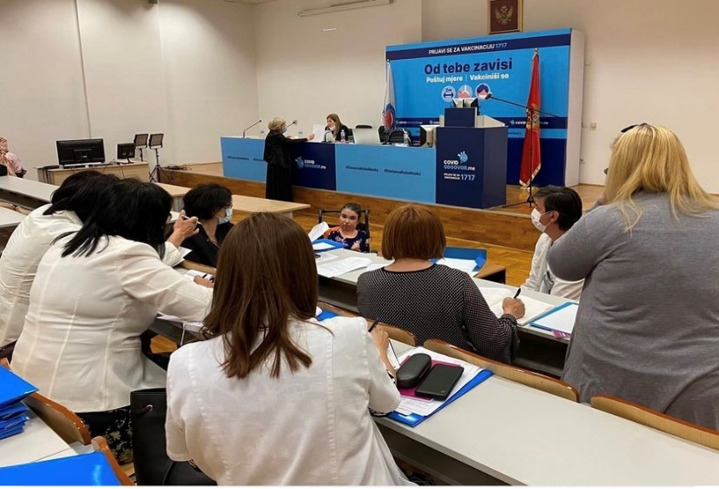
As the project aims to develop a methodology for disability assessment in line with social and human rights-based model of disability assessment promoted by the UN Convention on the Rights of Persons with Disabilities, the groups include experts from all relevant fields, including experts from the existing assessment and determination system, medical doctors from various fields of medicine (ophthalmologists, audiologists, internists, neurologists, orthopaedics, gynaecologists, psychiatrists, paediatricians, occupational medicine, surgeons, physiatrists); representatives of other occupations involved in the care for persons with disabilities (psychologists, social workers, physiotherapists, work therapists). In line with slogan Nothing about us without us, IPH announced and re-announced call for 12 OPD representatives including associations of parents of children with disabilities, yet only 7 representatives applied and are actively taking part.
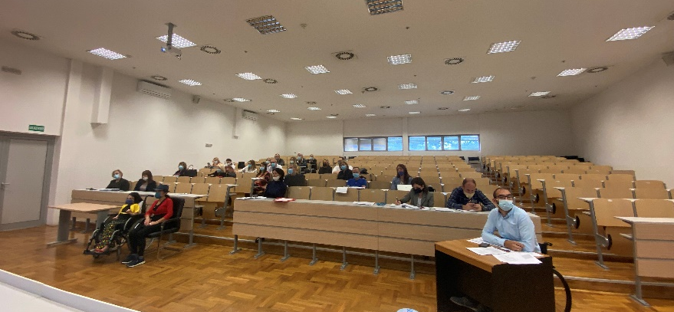
The CRPD concept of disability is relational, it recognises the interaction between impairment and barriers which hinder their ‘full and effective participation in society on an equal basis with others’. Therefore, methods and criteria for disability assessment/determination will be designed in a way to reflect on all important segments of disability: impairment, functionalities and the most important – interaction with barriers and the individual’s support needs.
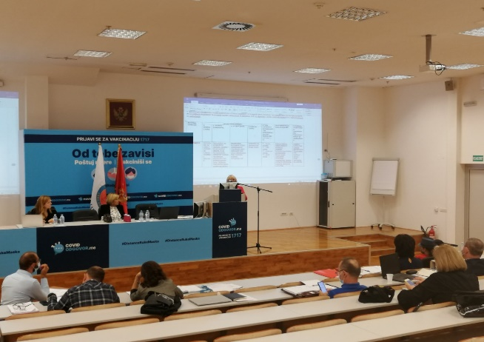
Since end of May, IPH task force groups are working on developing draft of the List of Impairments and List of Functional Abilities. This process is in final phase of providing and addressing comments of task force groups members and finetuning. The final draft is expected to be completed by the end of November, when it will be shared with all relevant stakeholders for further discussion. The third segment of disability assessment/determination criteria is assessment of interaction with barriers and the individual’s support needs. This is the most challenging part of methodology. This segment will consider the perspective of the assessed individual through the questionary that will be part of the application document submitted by the individual. Also, the assessment process will include face-to-face interview with the applicant. Task Force groups are currently working on designing a structured questionary on barriers and individual support needs, as well as methodology for their assessment. The first draft is expected to be completed by the end of the 2021. More photos from meetings of Task force groups can be found here.
A.1.3. Creation and adoption of new normative framework, encompassing law and bylaws
As elaborated above, Ms Ljubinka Vukajlović has been engaged as Legal Expert for supporting developing new legal framework for disability assessment/determination. With 27 years’ experience as a legal expert in the national Secretariat for Legislation of Montenegro, she has extensive experience with drafting, reviewing, aligning, analysing drafts and bills of laws, by-laws and other regulations, in the area of social and child protection, employment, pension and disability insurance, war veteran sectors. She prepared an Analysis of the existing legal framework with proposal for amendment of existing legal norms. Also, she prepared zero draft of the Law on Unified Disability Assessment, that has been presented to IWG. After several iterations of comments and suggestions addressed, the draft law was prepared and submitted to the MFSS, for further proceeding. MFSS informed UNDP that adoption of the law has been postponed for the second quarter of 2022. Meantime, OPDs suggested that there is space for further considerations, improvements, therefore IWG will continue its work on draft law.
As presented under the Activity 1.1., the SC members proposed extension of composition of IWG. Therefore, due to its wide memberships’ composition (23 members), Project Team formed a compact Task Force Team to support development of the first draft of Decree as part of the new normative framework. Task Force Team is composed of one representative of each relevant sector. These are lawyers with extensive practical experience with implementation of the existing legal framework. Its compact composition enables a higher level of efficiency and responsiveness. All documents developed by the Task Force Team are to be duly presented, discussed and adopted with IWG. Currently, Task Force Team is focused on developing Decree on Methodology of Disability Assessment and Expert opinion template, together with international experts and legal expert support provided by the project.
The Project Team is planning to recruit a consultant for the impact assessment of the introduction of the new disability assessment system (RIA analysis) by the end of 2021.
Result Area 2: Institutional rightsizing and reorganization
Activity 2.4. Promotion, information sharing and education
In line with the guiding principles of the project Nothing About Us Without Us, ensuring adequate representation and effective participation of OPDs throughout the process is crucial for its legitimacy. This principle is reflected in all implemented and ongoing activities. So far, three calls for in total 17 OPDs representatives in different project entities have been published. OPD representatives and PwDs are members of SC, IWG, five Task Force groups established by IPH, Taskforce Team. Yet, the number of OPD representatives who are engaged is still below the expected.
Following the approval of SC, the first Call for Proposals for the allocation of grants for the implementation of promotional and educational activities was published on June 29, 2021. Information about the Call was published on UNDP website, daily newspapers and circulated via CRNVO E-mail list to all NGOs registered in Montenegro. In order to provide detailed information about the call, application procedure and selection criteria to potential applicants, an online consultative session has been organized on July 6, 2021. The total eligible amount of funding under this Call was 50,000 EUR.

The priority areas to be addressed with this Call were presented and discussed with OPDs during Launch Conference organized on June 2, 2021. More info on Call can be found here.

By the set deadline, UNDP received proposals from eight NGOs. The evaluation process was two-phased. As a result of the preliminary evaluation, five out of eight applicants scored more than 70 points, therefore was shortlisted for the second phase. Before the final decision was made, a number of consultative meetings were organized with NGOs, and they have submitted improved project proposals. Under the first Call for Proposals 49,542 EUR was allocated for five project proposals. For more info on the evaluation process please refer to Evaluation Meeting Minutes.
UNDP signed Law Value Grant Agreements with five NGOs in September. Duration of contracts varies from 4 to 12 months, while budget ranges between 7,000 to 12,000 EUR.
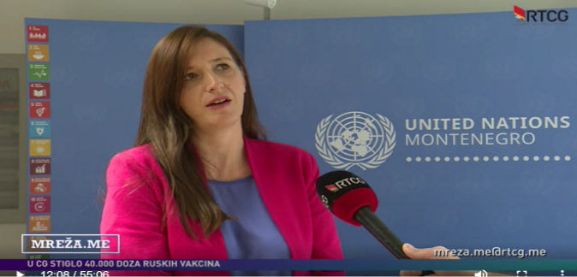
Contract signature was followed by press release about distribution of grants, published on UNDP website and EU Info Centre, as well as in multiple media. Also, Programme Manager, Ms Aleksandra Višnjić participated in the TV format MREŽA.ME at RTCG were she presented grant scheme. Press clipping with links to all materials can be found here.

Key activities of the selected NGO’s projects:
Initiative of Youth with Disabilities of Boka: Training for members of working groups for the Reform of Disability Assessment System; Workshops for PWDs and this would include organization of four workshops for users of different institutions, and it will address the topics such as rights of PWDs, in particular persons with intellectual disabilities, persons with mental illness, persons with hearing and/or speech impairments; Legal advocacy and Media and awareness-raising campaign.
Union of the Blind of Montenegro: Wide media campaign with the aim of educating public about correct terminology, approach to disability from the angle of the social model and the model based on human rights and gender equality; the principle of anti-discrimination, equality and accessibility of Information; employment, salary subsidies, hiring an assistant, workplace adjustment, so-called workplace equipment, choice of jobs, diversity of job choices conditioned by (im)possibility of acquiring knowledge.
Centre for Civic Education: Production of short video stories of everyday life of PWDs - "One day with me"; Production of the Media Handbook on Inclusive Reporting on PWD; Competition for the best journalistic story about disability; "PWD on film" - a film on PWD themes that will be screened at the Montenegrin Film Festival on Human Rights ACCELERATION and within the same film festival - organization of a panel discussion with the working title "PWD between capabilities and barriers in Montenegro".
Ekvivalent: Organizing eight educational workshops, in eight different towns in Montenegro, for persons with disabilities, parents and guardians of persons with disabilities and representatives of NGOs for the protection of the rights of persons with disabilities. Media campaign is going to follow these activities and with the aim of ensuring better media coverage, range of MoU with different media is going to be signed.
Association for assistance to persons with disabilities Niksic: Informing and educating representatives of local institutions, citizens, PWD and their family members on the position of PWD and their rights, but they will also inform about the new system of the disability determination/assessment. These are going to be done through workshops, brochures and through work with media who are also going to be educated about above mentioned topics.
Set consisted of Project Implementation Manual and Communication and Visibility Guidelines was prepared by Project Team and distributed to all grantees. UNDP Project Team conducted series of meetings with NGOs, in order to meet project teams and provide additional clarifications about the process.
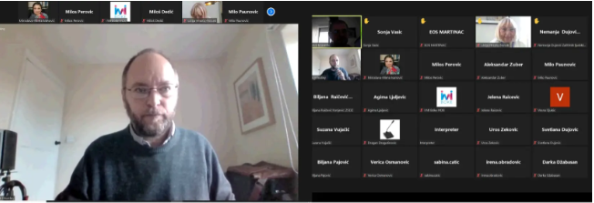
Some grant recipients have already started with the implementation of activities. Namely, within the project "EduAction for Disability Rights", the Initiative of Youth with Disabilities of Boka (IYDB) organized a Webinar for members of IWG and IPH Taskforce Groups. Also, an invitation to join webinar was shared via the OPD mailing list. Webinar was led by Prof. Mark Priestley, Professor of Disability Policy at the School of Sociology and Social Policy at the University of Leeds in the UK. Prof. Priestley is the co-author of the Report of the Academic Network of European Disability Experts (ANED) "Disability Assessment in European States ANED Synthesis Report", which includes an analysis of the disability assessment system in 34 European countries. Participants had an opportunity to have insight into different experiences of countries across Europe in developing and implementing disability assessment systems. The webinar provided participant with perspective on what CRPD-compliant disability assessment could look like. NGO IYDB is currently preparing an accessible version of the webinar. The material will be published on the UNDP project page and IYDB website, as well as shared with members of all working groups and via OPD mailing list. More info on webinar can be found here.

DIFFICULTIES ENCOUNTERED AND MEASURES TAKEN TO OVERCOME PROBLEMS AND EVENTUAL CHANGES INTRODUCED

Due to the complicated political and epidemiological situation in the country, start of the project was postponed on two occasions. Initially, the reasons were complicated epidemiological situations caused by the COVID-19 pandemic and change of the Government and the structure of the line Ministries. The additional postponement was caused by the long-lasting process of appointment of Government members of the Project Steering Committee. To mitigate potential delays of planned activities, Project Team intensified work on establishing all relevant task force groups immediately upon appointment of SC, coordinated their work and therefore managed to stay in line with the work plan.
During the launch event, OPDs initiated necessity to develop the glossary of key terms important for the Project’s implementation and new legislative framework. Discussion on definitions of disability-related terms lasts for more than a decade in Montenegro. In order to support this important process and endorse the OPD initiative to define and include the terminology list in Law on Unified Disability Assessment, UNDP organizes and coordinates an extensive series of discussions between OPDs. Since OPDs do not have a unified position on the meaning of several important terms, Project Team decided to engage international expert Mr Damjan Tatić to prepare a proposal of the glossary in line with UN CRPD. Still, with all the UNDP efforts invested, the discussion on the proposed glossary is still ongoing without a consensus among the OPDs.

Visibility and Communication

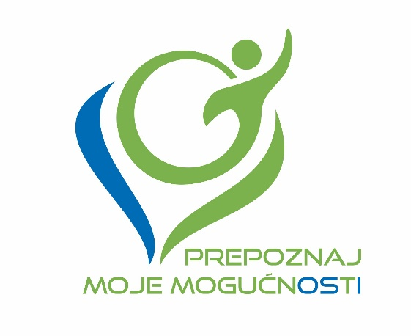
Implementation of the Communication and Visibility Plan, adopted in April this year, is going according to scheduled dynamics and, it is supported with different advocacy activities with OPDs. At the beginning of the project, the slogan Prepoznaj moje mogućnosti and logo of the project were designed. Key communication messages were developed and different communicators for distinct areas covered by this project were recognized and listed, so we have them ready in case the necessity for specific communication arise.

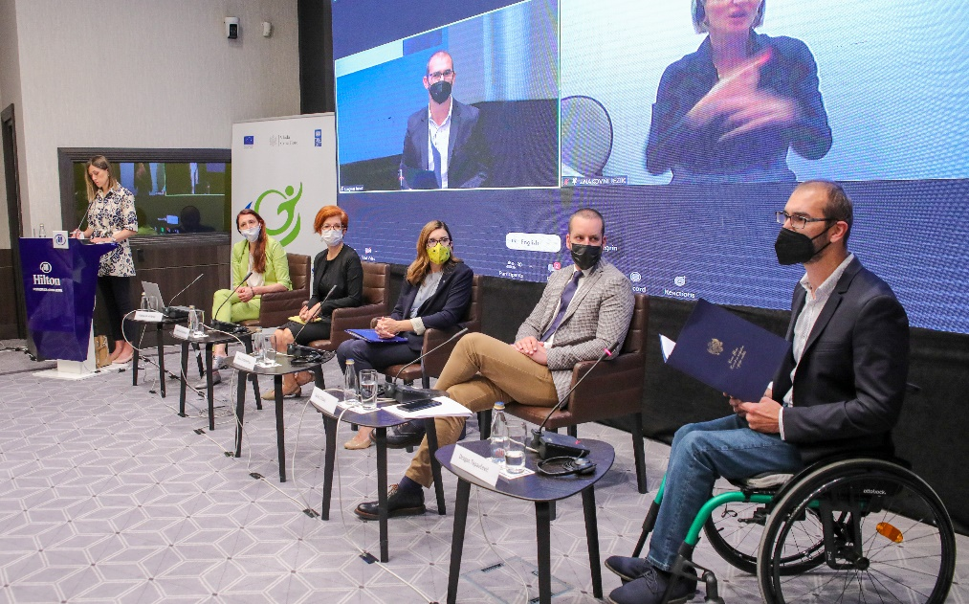
The launching Conference Reform of National Disability Determination System – Recognize my (dis)Abilities was organized and successfully delivered on June 2nd, 2021. The gathering was opened by the State Secretary at the Ministry of Finance and Social Welfare Mr Janko Odović, EU Ambassador to Montenegro Ms Oana Kristina Popa and UNDP Resident Representative for Montenegro Ms Daniela Gasparikova. Opening addresses were closed by social worker Mr Dragan Tepavčević who emphasized the importance of this reform from a perspective of person with a disability. The event was organized in a hybrid format due to imposed COVID-related measures. First panel was dedicated to presentation of the Project and attended by representatives of all relevant sectors and institutions as well as OPDs representatives. The second panel Cooperation with non-governmental organizations (NGOs), was devoted OPDs. Ms Mirjana Ivanovic presented Communication and Visibility Plan, grant scheme and discussed previously developed themes that would be covered by Call for grants. DPO representatives suggested developing a glossary of terms relevant for this Project. In total 62 participants attended Conference, 26 in Hotel Hilton, while 36 joined via Zoom platform. Simultaneous translation into sign language has been provided. For more info on event please refer to press clipping and photos.

As an additional communication tool particularly important during COVID pandemic, UNDP created Disability System Reform mailing list with more than 80 email address of all relevant DPOs and their representatives, while Project Team agreed to create a Viber Community as well. Those tools will be used for communication of all important activities with OPDs.

In line with C&V Plan, the call for grants was developed and published in media and communicated via the CRNVO network and UNDP mailing list. More on grants under Activity 2.4. Besides the Communication and Visibility Plan for the Project, the separate C&V plan is developed for the activities implemented by NGO projects, financed through grants. The aim is to have better coordination of activities, avoid their overlapping to the extent possible, and therefore have better media coverage and public reach of the activities.

All NGOs stated their interest and willingness to participate in the UNDP organized workshop that would tend to enhance their communication skills. Due to the variety of areas, they expressed interest in, the workshop would cover basics of communications, how to develop and implement campaign, cooperation with media and use of social networks in communication.

At the moment, implementation of the project activities is ongoing, and it is closely followed by UNDP Project Team and Communication Consultant.

Summary of resources deployed during the reporting period
During the reporting period 186,836.49 USD were spent out of 252,163 USD (the first pre-financing instalment). The financial Progress report is enclosed as Annex 1. A List of Legal Commitments can be found here.
Also, there is a minor change in recording expenditures under the budget category Project Management, budget position National Personnel. Namely, UNDP has two contractual modalities for national personnel. Therefore, depending on the contractual model used, in accordance with UNDP operational procedures, expenses are recorded under UNDP account codes: 61200 (National personnel – Fixed Term Appointment) or 71400 (Service contract (SC) for individuals - National Personnel Service Agreement). Under the budget line National Personnel, the approved budget envisages 10% of costs for the Communication Officer will be charged from account 61200. However, since the Communication Officer is SC holder, our system records this cost under 71400 instead. Therefore, this change refers only to accounting procedures (changes of accounting code within the same budget line) and it does not affect the main purpose of the Action, nor it has a financial impact on the approved budget.

Work Plan for the upcoming period
Following activities will be implemented in the upcoming 2-year period:
- A.1.1. Intersectoral Working Group established and functioning
- A.1.2. Comprehensive list and Uniform criteria developed
- A.1.3. New law(s) and bylaw(s) adopted
- A.2.1. Overall legal establishing the Commission, professional staff recruitment, and support to the initial functioning of the Commission
- A.2.2. Adaptation and equipping of the premises
- A.2.3. Development and implementation of Training Program
- A.2.4. Promotion, information sharing and education
- A.2.5. Development and implementation of the new Information System and PWD E-Registry
- A.2.6. New system piloting phase
The updated workplan for the upcoming period could be found here.

Annexes
Annex 1 Financial Progress Report
Annex 2 Workplan
Annex 4 List of Legal Commitments
Annex 5 Request for payment
Annex 7 Management Declaration

